Learning Goal
Developing my portfolio in a version control environment.
Action
Throughout the development of my portfolio, I used Git as the version control system, following a structured approach to manage changes and track progress. Each step of my development process was carefully committed to GitLab, ensuring that I could easily roll back or iterate on previous versions as I implemented new features. Here's a breakdown of the steps I took, reflected in my GitLab commits:
- Base HTML Structure: Established the scene in HTML, providing the canvas and initial elements for the 3D environment.
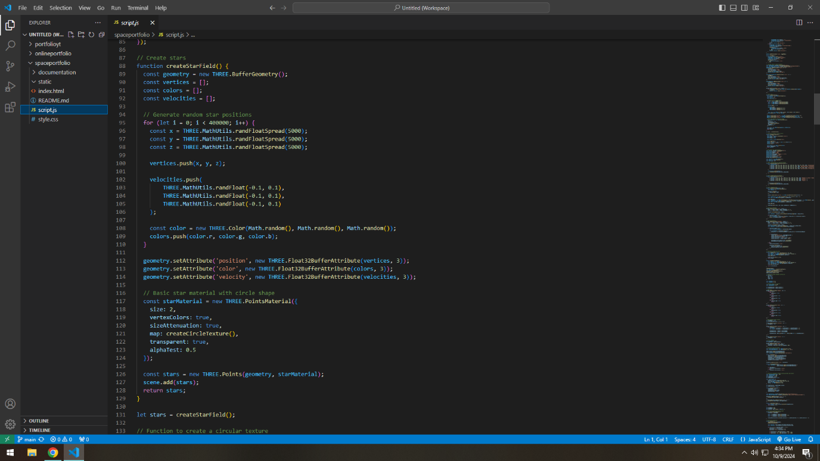
- Create the Star Field: Using Three.js, I implemented a function to create stars with random positions, velocities, and colors. Each commit represented milestones like adding the star field, refining star properties, and introducing Create the Planet: I introduced a central planet in the scene and created a menu on the planet to serve as the main navigation interface.
- Camera Navigation: Developed a camera navigation system that allowed users to move through space using keyboard controls (W, A, S, D) and mouse controls (dragging and zooming). This feature was committed incrementally as I added functionalities and optimized camera behaviour.
- Menu Design: Added a dropdown menu for navigating between constellations (representing learning outcomes and projects). Styling improvements and bug fixes were tracked through Git commits, ensuring I had a full history of CSS updates.
- Create Constellations: I created groups of stars connected by lines, forming constellations for learning outcomes and projects. These were progressively enhanced, with each constellation creation reflected in my version control history.
- Enhanced Interactivity: Implemented hover functionality on constellations and moving stars, improving the user experience. Commits documented each stage of interactivity, from basic hover logic to more refined animations.
- Responsiveness: Ensured the site was responsive across devices, tracked through Git as I tested and improved the design for different screen sizes.
- Iteration: After receiving feedback, I made enhancements such as modifying the dropdown menu's CSS and improving visual cues for interactivity. These changes were committed with clear messages reflecting the iterative nature of the project.
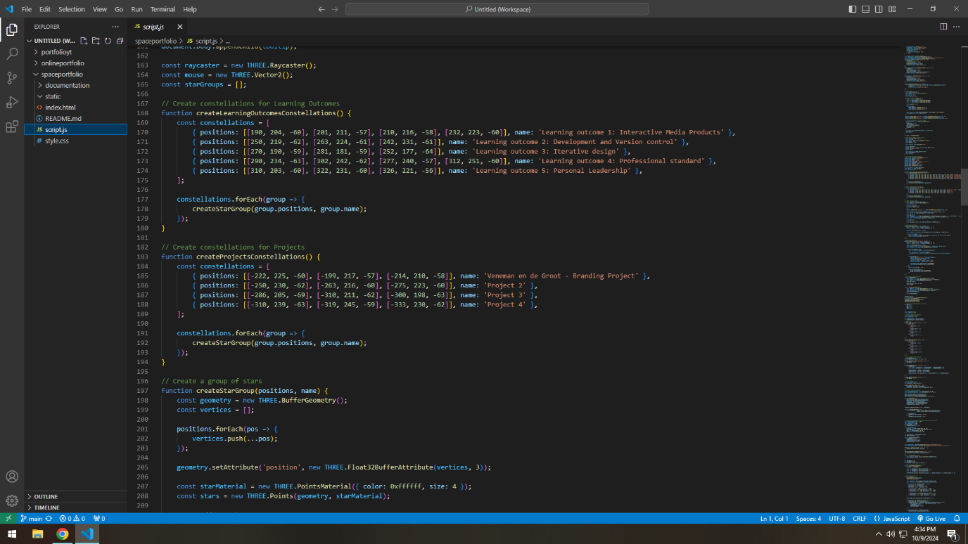

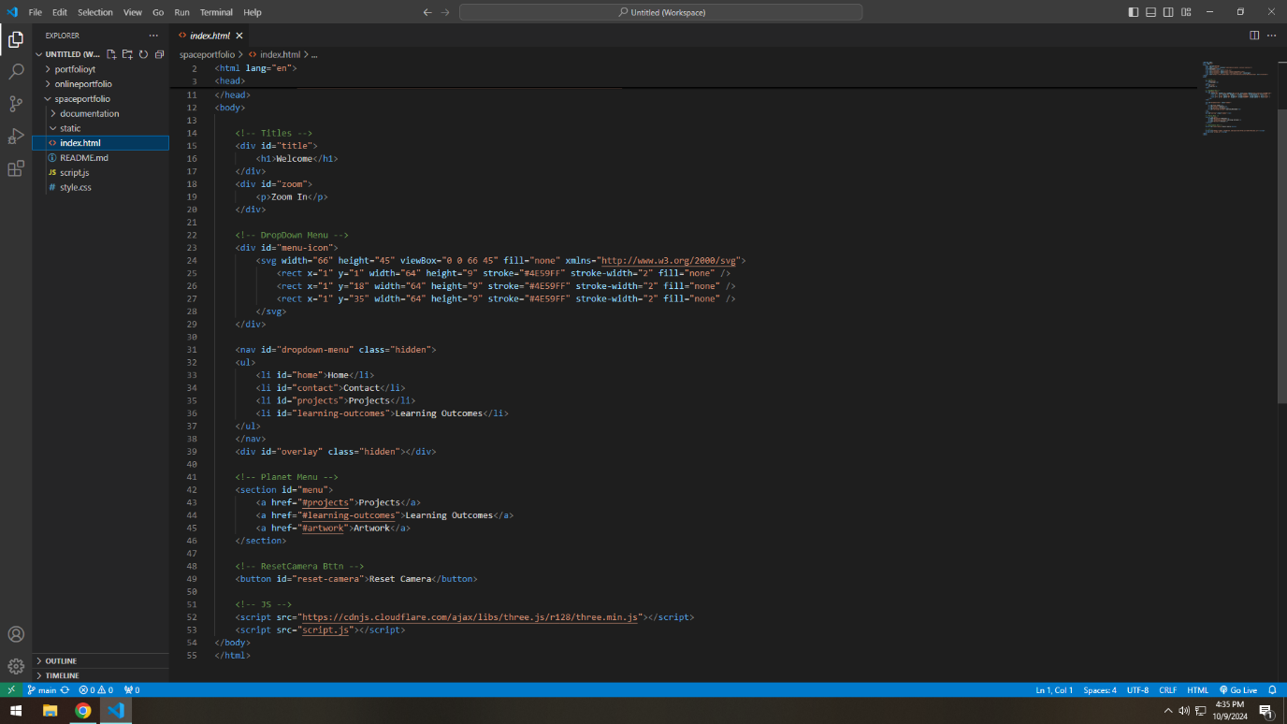
Result
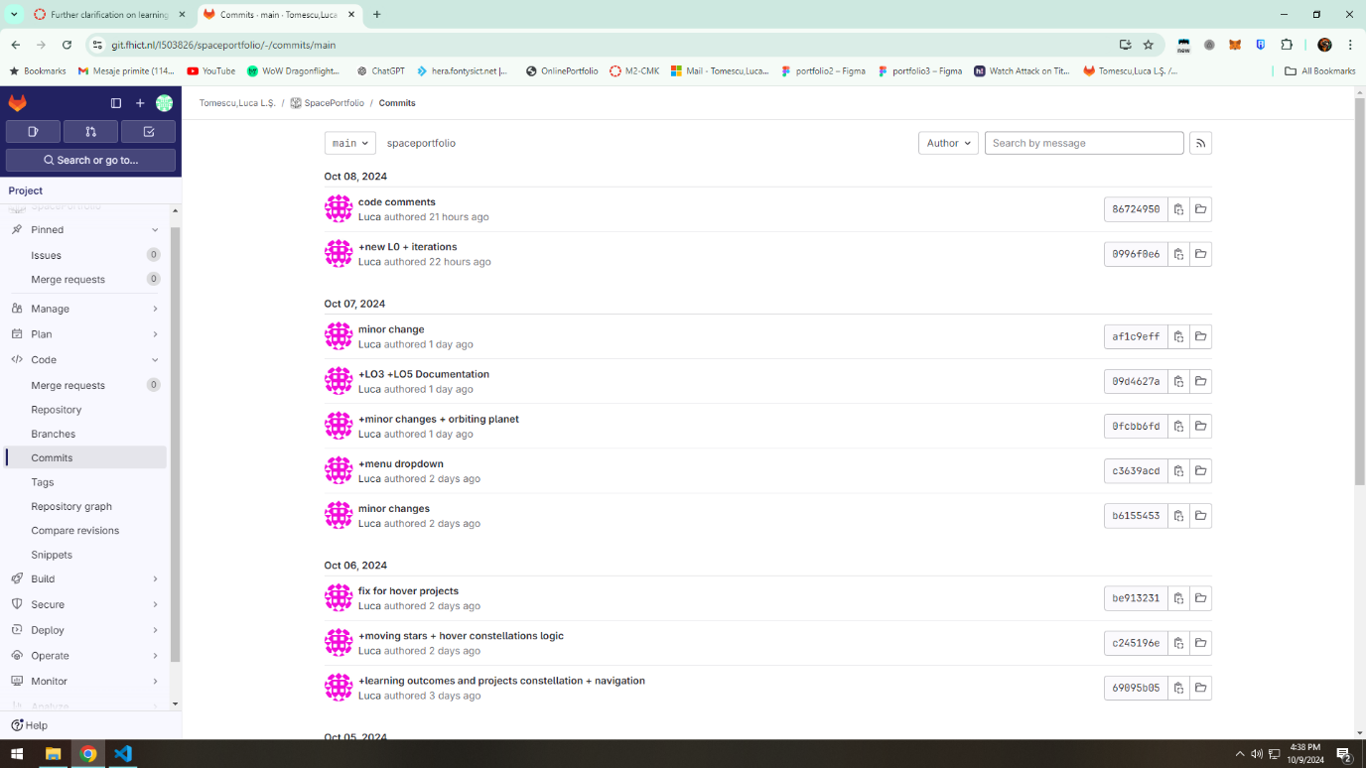
By using Git as my version control environment, I maintained a clear and organized record of my development process, which allowed for effective iteration and feedback integration. The result was an interactive, 3D portfolio website that showcased my work in a visually engaging way. The use of Git helped me manage the complexity of the project, ensuring each feature was implemented smoothly and could be reverted or improved as needed.
Feedback
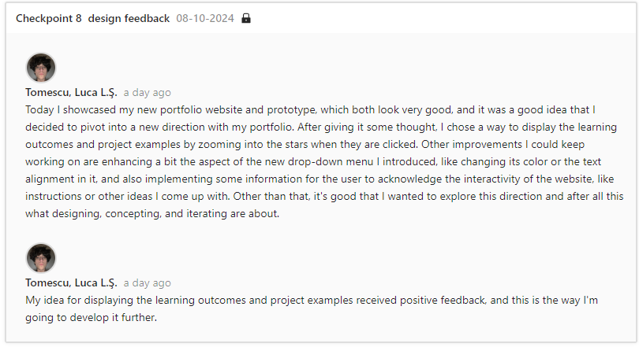
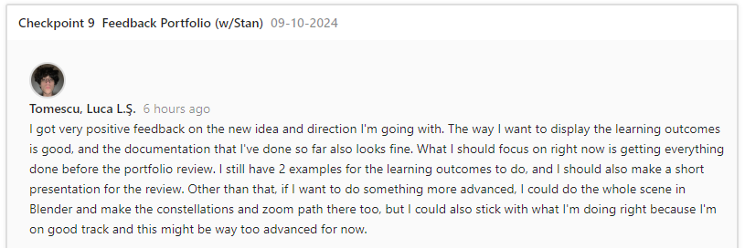
I received positive feedback on the overall design, particularly the interactive space and smooth camera navigation. The constructive feedback included suggestions to enhance the dropdown menu's CSS for better usability and to make it clearer that the website was interactive. Additionally, I was encouraged to explore more advanced 3D design techniques using Blender and to experiment with pre-coded camera trajectories for a more immersive user experience.
Reflection
Using Git throughout the project provided invaluable support in managing the development process. Each step was meticulously tracked, making it easy to revisit earlier versions and refine features based on feedback. This experience reinforced the importance of version control in managing complex web development projects, especially when iterating frequently. The feedback on Blender also opened new pathways for future development, encouraging me to experiment with even more immersive portfolio designs.
Decide
Moving forward, I will continue to use Git for version control in all my projects, as it has proven essential in maintaining organization and structure. I plan to explore Blender as a tool to further enhance my 3D portfolio designs. Additionally, I will refine my approach to interactive design, focusing on improving user experience by making interactivity more intuitive from the start.

